hate as no-offensive

alpha=2

1 run......

training 1 epoch...

16.61301350593567 seconds used......

1 training finished! average train loss: 2.138663494161197

total clf loss: 53.83340048789978 total adv loss: 32.96587771177292

evaluating...

Confusion matrix, without normalization

[[ 56 19 21]

[ 62 206 87]

[ 51 80 588]]

Normalized confusion matrix

[[0.58333333 0.19791667 0.21875 ]

[0.17464789 0.58028169 0.24507042]

[0.07093185 0.11126565 0.8178025 ]]

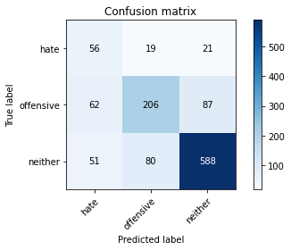

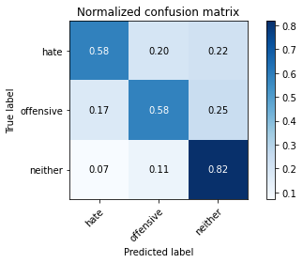

precision recall f1-score support

hate 0.33 0.58 0.42 96

offensive 0.68 0.58 0.62 355

neither 0.84 0.82 0.83 719

accuracy 0.73 1170

macro avg 0.62 0.66 0.63 1170

weighted avg 0.75 0.73 0.73 1170

average eval_loss: 0.6839279340485395, accuracy: 0.7264957264957265

training 2 epoch...

16.672187089920044 seconds used......

2 training finished! average train loss: 1.4094770678452082

total clf loss: 33.90628606081009 total adv loss: 22.512215048074722

evaluating...

Confusion matrix, without normalization

[[ 83 7 6]

[ 87 221 47]

[ 84 117 518]]

Normalized confusion matrix

[[0.86458333 0.07291667 0.0625 ]

[0.24507042 0.62253521 0.13239437]

[0.11682893 0.16272601 0.72044506]]

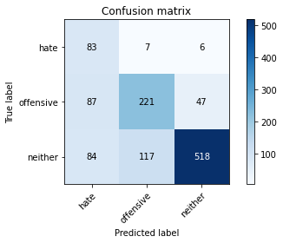

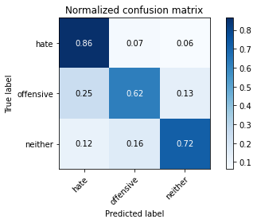

precision recall f1-score support

hate 0.33 0.86 0.47 96

offensive 0.64 0.62 0.63 355

neither 0.91 0.72 0.80 719

accuracy 0.70 1170

macro avg 0.62 0.74 0.64 1170

weighted avg 0.78 0.70 0.72 1170

average eval_loss: 0.7155760521605864, accuracy: 0.7025641025641025

training 3 epoch...

16.760204315185547 seconds used......

3 training finished! average train loss: 0.6663079695510012

total clf loss: 16.960858553647995 total adv loss: 10.176193850114942

evaluating...

Confusion matrix, without normalization

[[ 88 4 4]

[123 197 35]

[144 90 485]]

Normalized confusion matrix

[[0.91666667 0.04166667 0.04166667]

[0.34647887 0.55492958 0.09859155]

[0.20027816 0.12517385 0.67454798]]

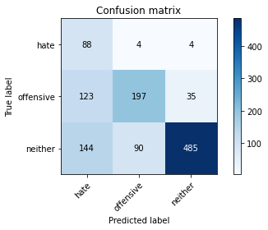

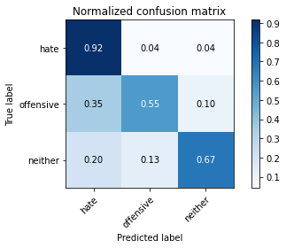

precision recall f1-score support

hate 0.25 0.92 0.39 96

offensive 0.68 0.55 0.61 355

neither 0.93 0.67 0.78 719

accuracy 0.66 1170

macro avg 0.62 0.72 0.59 1170

weighted avg 0.79 0.66 0.70 1170

average eval_loss: 1.0116941459098105, accuracy: 0.6581196581196581

training 4 epoch...

16.653680086135864 seconds used......

4 training finished! average train loss: 0.28318973125091623

total clf loss: 8.520883675664663 total adv loss: 3.6688706459244713

evaluating...

Confusion matrix, without normalization

[[ 84 4 8]

[107 170 78]

[ 77 45 597]]

Normalized confusion matrix

[[0.875 0.04166667 0.08333333]

[0.30140845 0.47887324 0.21971831]

[0.10709318 0.06258693 0.83031989]]

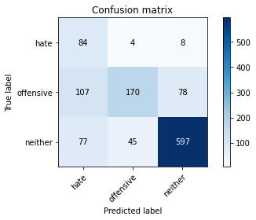

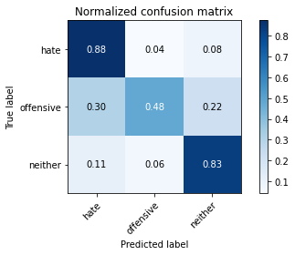

precision recall f1-score support

hate 0.31 0.88 0.46 96

offensive 0.78 0.48 0.59 355

neither 0.87 0.83 0.85 719

accuracy 0.73 1170

macro avg 0.65 0.73 0.64 1170

weighted avg 0.80 0.73 0.74 1170

average eval_loss: 0.88019977333182, accuracy: 0.7273504273504273

training 5 epoch...

16.645711183547974 seconds used......

5 training finished! average train loss: 0.10486151341215841

total clf loss: 3.419613034464419 total adv loss: 1.2263158785935957

evaluating...

Confusion matrix, without normalization

[[ 77 9 10]

[ 71 218 66]

[ 56 72 591]]

Normalized confusion matrix

[[0.80208333 0.09375 0.10416667]

[0.2 0.61408451 0.18591549]

[0.07788595 0.10013908 0.82197497]]

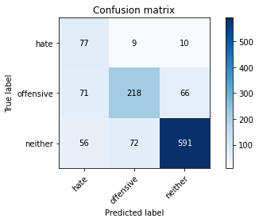

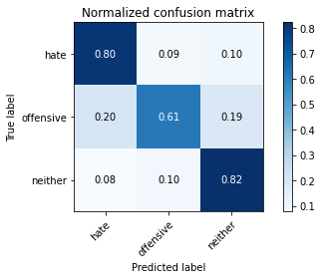

precision recall f1-score support

hate 0.38 0.80 0.51 96

offensive 0.73 0.61 0.67 355

neither 0.89 0.82 0.85 719

accuracy 0.76 1170

macro avg 0.66 0.75 0.68 1170

weighted avg 0.80 0.76 0.77 1170

average eval_loss: 0.8615743937128681, accuracy: 0.7572649572649572

training 6 epoch...

16.794490814208984 seconds used......

6 training finished! average train loss: 0.07925532397348434

total clf loss: 2.3808496175333858 total adv loss: 1.02872424369707

evaluating...

Confusion matrix, without normalization

[[ 80 11 5]

[ 55 251 49]

[ 74 105 540]]

Normalized confusion matrix

[[0.83333333 0.11458333 0.05208333]

[0.15492958 0.70704225 0.13802817]

[0.10292072 0.14603616 0.75104312]]

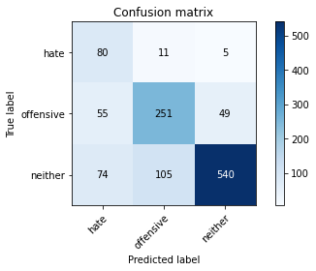

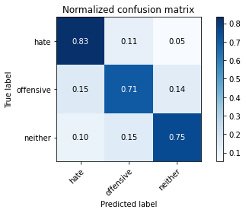

precision recall f1-score support

hate 0.38 0.83 0.52 96

offensive 0.68 0.71 0.70 355

neither 0.91 0.75 0.82 719

accuracy 0.74 1170

macro avg 0.66 0.76 0.68 1170

weighted avg 0.80 0.74 0.76 1170

average eval_loss: 0.8984920768919638, accuracy: 0.7444444444444445

training 7 epoch...

16.7686288356781 seconds used......

7 training finished! average train loss: 0.053787552211101035

total clf loss: 1.477866804227233 total adv loss: 0.7671180796824046

evaluating...

Confusion matrix, without normalization

[[ 70 16 10]

[ 62 226 67]

[ 74 85 560]]

Normalized confusion matrix

[[0.72916667 0.16666667 0.10416667]

[0.17464789 0.63661972 0.18873239]

[0.10292072 0.11821975 0.77885953]]

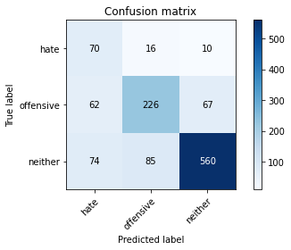

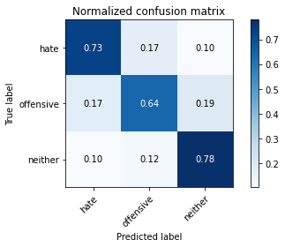

precision recall f1-score support

hate 0.34 0.73 0.46 96

offensive 0.69 0.64 0.66 355

neither 0.88 0.78 0.83 719

accuracy 0.73 1170

macro avg 0.64 0.71 0.65 1170

weighted avg 0.78 0.73 0.75 1170

average eval_loss: 1.0225610207703153, accuracy: 0.7316239316239316

training 8 epoch...

16.684913396835327 seconds used......

8 training finished! average train loss: 0.03356112364313698

total clf loss: 0.9608960228506476 total adv loss: 0.4592634410801111

evaluating...

Confusion matrix, without normalization

[[ 86 9 1]

[ 79 198 78]

[117 54 548]]

Normalized confusion matrix

[[0.89583333 0.09375 0.01041667]

[0.22253521 0.55774648 0.21971831]

[0.16272601 0.07510431 0.76216968]]

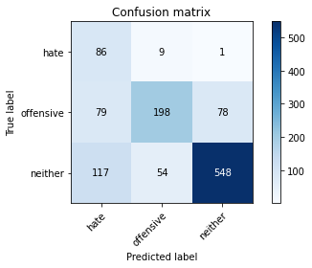

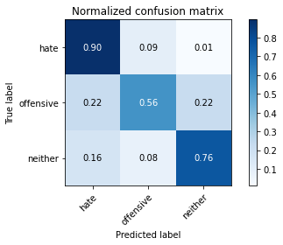

precision recall f1-score support

hate 0.30 0.90 0.46 96

offensive 0.76 0.56 0.64 355

neither 0.87 0.76 0.81 719

accuracy 0.71 1170

macro avg 0.65 0.74 0.64 1170

weighted avg 0.79 0.71 0.73 1170

average eval_loss: 1.2033107174655138, accuracy: 0.7111111111111111

training 9 epoch...

16.713977098464966 seconds used......

9 training finished! average train loss: 0.10207148260919244

total clf loss: 2.279270655591972 total adv loss: 1.7183662098977948

evaluating...

Confusion matrix, without normalization

[[ 79 10 7]

[ 61 222 72]

[ 83 81 555]]

Normalized confusion matrix

[[0.82291667 0.10416667 0.07291667]

[0.17183099 0.62535211 0.2028169 ]

[0.11543811 0.11265647 0.77190542]]

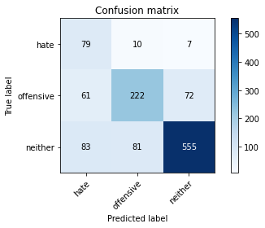

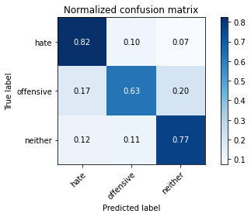

precision recall f1-score support

hate 0.35 0.82 0.50 96

offensive 0.71 0.63 0.66 355

neither 0.88 0.77 0.82 719

accuracy 0.73 1170

macro avg 0.65 0.74 0.66 1170

weighted avg 0.78 0.73 0.75 1170

average eval_loss: 1.0871031147948766, accuracy: 0.7316239316239316

training 10 epoch...

16.76847767829895 seconds used......

10 training finished! average train loss: 0.09641905959246547

total clf loss: 1.677029953803867 total adv loss: 1.8612186498357914

evaluating...

Confusion matrix, without normalization

[[ 53 30 13]

[ 21 268 66]

[ 31 127 561]]

Normalized confusion matrix

[[0.55208333 0.3125 0.13541667]

[0.05915493 0.75492958 0.18591549]

[0.04311544 0.17663421 0.78025035]]

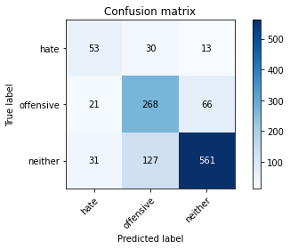

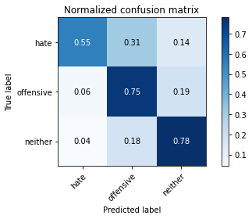

precision recall f1-score support

hate 0.50 0.55 0.53 96

offensive 0.63 0.75 0.69 355

neither 0.88 0.78 0.83 719

accuracy 0.75 1170

macro avg 0.67 0.70 0.68 1170

weighted avg 0.77 0.75 0.76 1170

average eval_loss: 0.9688693542601698, accuracy: 0.7538461538461538

2 run......

training 1 epoch...

16.64544653892517 seconds used......

1 training finished! average train loss: 2.2069089838436673

total clf loss: 55.297962844371796 total adv loss: 34.14447060227394

evaluating...

Confusion matrix, without normalization

[[ 48 27 21]

[ 50 230 75]

[ 36 156 527]]

Normalized confusion matrix

[[0.5 0.28125 0.21875 ]

[0.14084507 0.64788732 0.21126761]

[0.05006954 0.21696801 0.73296245]]

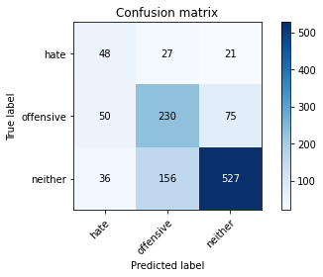

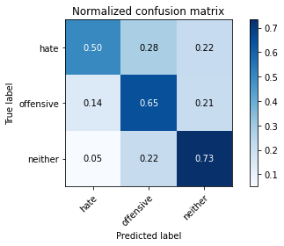

precision recall f1-score support

hate 0.36 0.50 0.42 96

offensive 0.56 0.65 0.60 355

neither 0.85 0.73 0.79 719

accuracy 0.69 1170

macro avg 0.59 0.63 0.60 1170

weighted avg 0.72 0.69 0.70 1170

average eval_loss: 0.7280848167710385, accuracy: 0.688034188034188

training 2 epoch...

16.77889847755432 seconds used......

2 training finished! average train loss: 1.6548588776162692

total clf loss: 38.60846596956253 total adv loss: 27.031815364956856

evaluating...

Confusion matrix, without normalization

[[ 84 8 4]

[100 200 55]

[107 107 505]]

Normalized confusion matrix

[[0.875 0.08333333 0.04166667]

[0.28169014 0.56338028 0.15492958]

[0.1488178 0.1488178 0.70236439]]

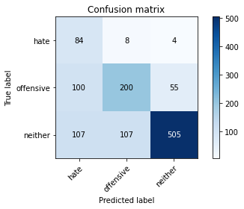

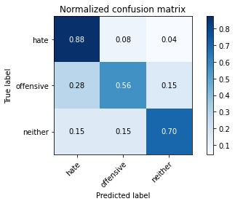

precision recall f1-score support

hate 0.29 0.88 0.43 96

offensive 0.63 0.56 0.60 355

neither 0.90 0.70 0.79 719

accuracy 0.67 1170

macro avg 0.61 0.71 0.61 1170

weighted avg 0.77 0.67 0.70 1170

average eval_loss: 0.764319056676606, accuracy: 0.6743589743589744

training 3 epoch...

16.740310192108154 seconds used......

3 training finished! average train loss: 0.9769999267799514

total clf loss: 22.75957164168358 total adv loss: 15.976211979985237

evaluating...

Confusion matrix, without normalization

[[ 80 12 4]

[ 62 243 50]

[ 94 130 495]]

Normalized confusion matrix

[[0.83333333 0.125 0.04166667]

[0.17464789 0.68450704 0.14084507]

[0.13073713 0.18080668 0.68845619]]

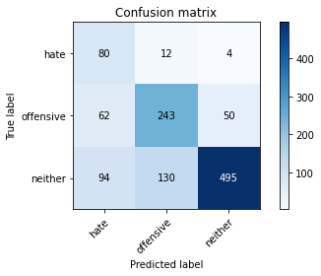

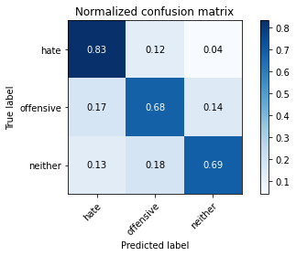

precision recall f1-score support

hate 0.34 0.83 0.48 96

offensive 0.63 0.68 0.66 355

neither 0.90 0.69 0.78 719

accuracy 0.70 1170

macro avg 0.62 0.74 0.64 1170

weighted avg 0.77 0.70 0.72 1170

average eval_loss: 0.841403533846645, accuracy: 0.6991452991452991

training 4 epoch...

16.696462154388428 seconds used......

4 training finished! average train loss: 0.313234493269452

total clf loss: 8.670499570667744 total adv loss: 4.435316120041534

evaluating...

Confusion matrix, without normalization

[[ 75 12 9]

[ 95 224 36]

[ 92 140 487]]

Normalized confusion matrix

[[0.78125 0.125 0.09375 ]

[0.26760563 0.63098592 0.10140845]

[0.12795549 0.19471488 0.67732962]]

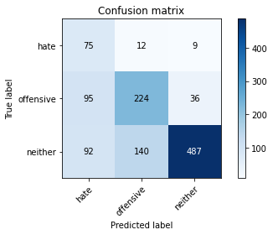

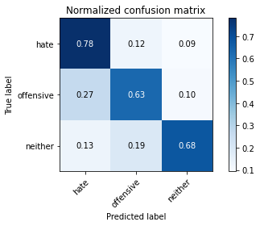

precision recall f1-score support

hate 0.29 0.78 0.42 96

offensive 0.60 0.63 0.61 355

neither 0.92 0.68 0.78 719

accuracy 0.67 1170

macro avg 0.60 0.70 0.60 1170

weighted avg 0.77 0.67 0.70 1170

average eval_loss: 1.0501491604215007, accuracy: 0.6717948717948717

training 5 epoch...

16.720916509628296 seconds used......

5 training finished! average train loss: 0.2129543771401846

total clf loss: 5.3568138517439365 total adv loss: 3.284315634984523

evaluating...

Confusion matrix, without normalization

[[ 82 8 6]

[ 74 217 64]

[ 95 78 546]]

Normalized confusion matrix

[[0.85416667 0.08333333 0.0625 ]

[0.2084507 0.61126761 0.18028169]

[0.13212796 0.10848401 0.75938804]]

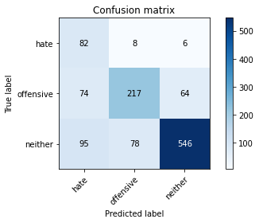

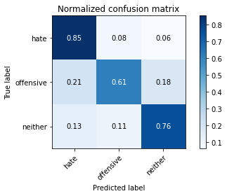

precision recall f1-score support

hate 0.33 0.85 0.47 96

offensive 0.72 0.61 0.66 355

neither 0.89 0.76 0.82 719

accuracy 0.72 1170

macro avg 0.64 0.74 0.65 1170

weighted avg 0.79 0.72 0.74 1170

average eval_loss: 0.971049050153312, accuracy: 0.7222222222222222

training 6 epoch...

16.79200553894043 seconds used......

6 training finished! average train loss: 0.14177135484559195

total clf loss: 3.5092236758209765 total adv loss: 2.214986120350659

evaluating...

Confusion matrix, without normalization

[[ 78 10 8]

[ 71 227 57]

[ 78 99 542]]

Normalized confusion matrix

[[0.8125 0.10416667 0.08333333]

[0.2 0.63943662 0.16056338]

[0.10848401 0.13769124 0.75382476]]

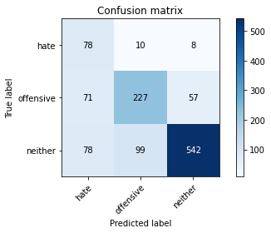

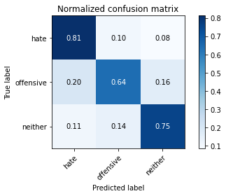

precision recall f1-score support

hate 0.34 0.81 0.48 96

offensive 0.68 0.64 0.66 355

neither 0.89 0.75 0.82 719

accuracy 0.72 1170

macro avg 0.64 0.74 0.65 1170

weighted avg 0.78 0.72 0.74 1170

average eval_loss: 1.0896596817646997, accuracy: 0.7239316239316239

training 7 epoch...

16.734354496002197 seconds used......

7 training finished! average train loss: 0.037595764467758794

total clf loss: 1.2186605739407241 total adv loss: 0.44335111961117946

evaluating...

Confusion matrix, without normalization

[[ 81 5 10]

[ 66 185 104]

[ 68 45 606]]

Normalized confusion matrix

[[0.84375 0.05208333 0.10416667]

[0.18591549 0.52112676 0.29295775]

[0.0945758 0.06258693 0.84283727]]

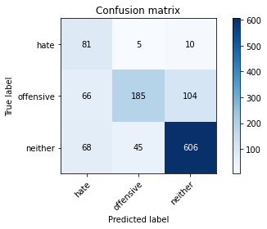

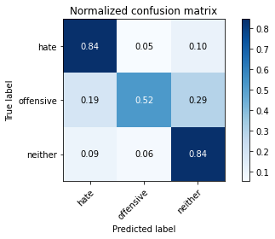

precision recall f1-score support

hate 0.38 0.84 0.52 96

offensive 0.79 0.52 0.63 355

neither 0.84 0.84 0.84 719

accuracy 0.75 1170

macro avg 0.67 0.74 0.66 1170

weighted avg 0.79 0.75 0.75 1170

average eval_loss: 1.081821415257656, accuracy: 0.7452991452991453

training 8 epoch...

16.74637246131897 seconds used......

8 training finished! average train loss: 0.03506653011260953

total clf loss: 0.7806390797486529 total adv loss: 0.5915432921392494

evaluating...

Confusion matrix, without normalization

[[ 82 8 6]

[ 69 242 44]

[ 81 127 511]]

Normalized confusion matrix

[[0.85416667 0.08333333 0.0625 ]

[0.1943662 0.68169014 0.12394366]

[0.11265647 0.17663421 0.71070932]]

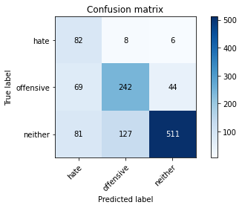

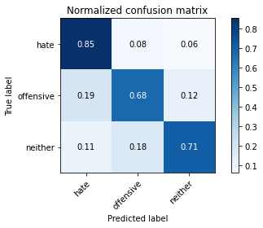

precision recall f1-score support

hate 0.35 0.85 0.50 96

offensive 0.64 0.68 0.66 355

neither 0.91 0.71 0.80 719

accuracy 0.71 1170

macro avg 0.64 0.75 0.65 1170

weighted avg 0.78 0.71 0.73 1170

average eval_loss: 1.3576499324733928, accuracy: 0.7136752136752137

training 9 epoch...

16.827325344085693 seconds used......

9 training finished! average train loss: 0.01892092327554045

total clf loss: 0.5302785073872656 total adv loss: 0.2646466041333042

evaluating...

Confusion matrix, without normalization

[[ 74 14 8]

[ 54 248 53]

[ 63 115 541]]

Normalized confusion matrix

[[0.77083333 0.14583333 0.08333333]

[0.15211268 0.69859155 0.14929577]

[0.0876217 0.15994437 0.75243394]]

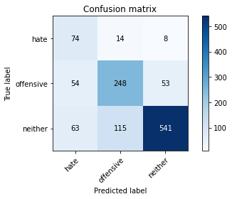

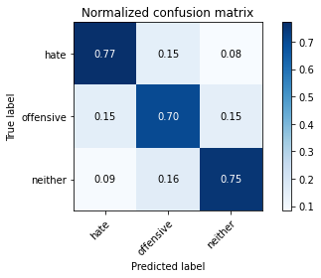

precision recall f1-score support

hate 0.39 0.77 0.52 96

offensive 0.66 0.70 0.68 355

neither 0.90 0.75 0.82 719

accuracy 0.74 1170

macro avg 0.65 0.74 0.67 1170

weighted avg 0.78 0.74 0.75 1170

average eval_loss: 1.192314886188103, accuracy: 0.7376068376068377

training 10 epoch...

16.76188039779663 seconds used......

10 training finished! average train loss: 0.003435284358732003

total clf loss: 0.17308645939920098 total adv loss: 0.009644732641390874

evaluating...

Confusion matrix, without normalization

[[ 79 9 8]

[ 69 233 53]

[ 74 106 539]]

Normalized confusion matrix

[[0.82291667 0.09375 0.08333333]

[0.1943662 0.65633803 0.14929577]

[0.10292072 0.14742698 0.74965229]]

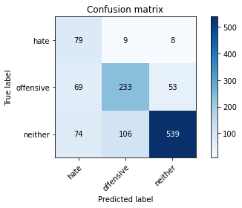

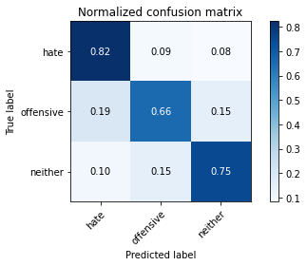

precision recall f1-score support

hate 0.36 0.82 0.50 96

offensive 0.67 0.66 0.66 355

neither 0.90 0.75 0.82 719

accuracy 0.73 1170

macro avg 0.64 0.74 0.66 1170

weighted avg 0.78 0.73 0.74 1170

average eval_loss: 1.3152892337007038, accuracy: 0.7273504273504273

3 run......

training 1 epoch...

16.722543239593506 seconds used......

1 training finished! average train loss: 2.185311332345009

total clf loss: 56.385033547878265 total adv loss: 32.99620056152344

evaluating...

Confusion matrix, without normalization

[[ 52 28 16]

[ 52 260 43]

[ 64 212 443]]

Normalized confusion matrix

[[0.54166667 0.29166667 0.16666667]

[0.14647887 0.73239437 0.12112676]

[0.08901252 0.29485396 0.61613352]]

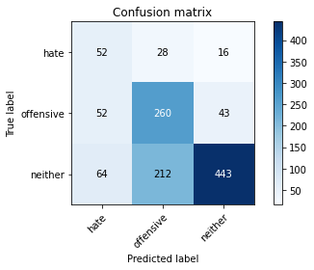

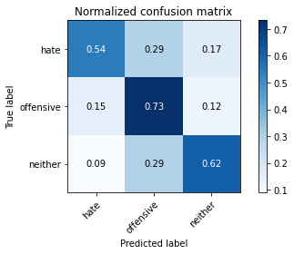

precision recall f1-score support

hate 0.31 0.54 0.39 96

offensive 0.52 0.73 0.61 355

neither 0.88 0.62 0.73 719

accuracy 0.65 1170

macro avg 0.57 0.63 0.58 1170

weighted avg 0.73 0.65 0.66 1170

average eval_loss: 0.7981229464886552, accuracy: 0.6452991452991453

training 2 epoch...

16.739983320236206 seconds used......

2 training finished! average train loss: 1.607015653380326

total clf loss: 38.77091920375824 total adv loss: 25.61097878217697

evaluating...

Confusion matrix, without normalization

[[ 59 17 20]

[ 46 180 129]

[ 39 44 636]]

Normalized confusion matrix

[[0.61458333 0.17708333 0.20833333]

[0.12957746 0.50704225 0.36338028]

[0.054242 0.06119611 0.88456189]]

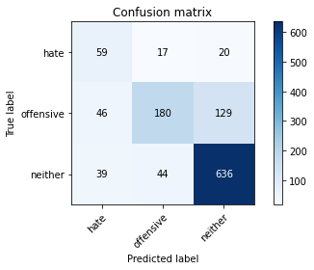

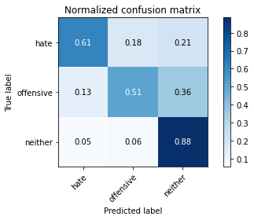

precision recall f1-score support

hate 0.41 0.61 0.49 96

offensive 0.75 0.51 0.60 355

neither 0.81 0.88 0.85 719

accuracy 0.75 1170

macro avg 0.66 0.67 0.65 1170

weighted avg 0.76 0.75 0.74 1170

average eval_loss: 0.5835777528710284, accuracy: 0.7478632478632479

training 3 epoch...

16.78640580177307 seconds used......

3 training finished! average train loss: 0.8934870819960322

total clf loss: 22.21637311577797 total adv loss: 13.909451704472303

evaluating...

Confusion matrix, without normalization

[[ 81 11 4]

[ 74 237 44]

[ 90 114 515]]

Normalized confusion matrix

[[0.84375 0.11458333 0.04166667]

[0.2084507 0.66760563 0.12394366]

[0.12517385 0.15855355 0.7162726 ]]

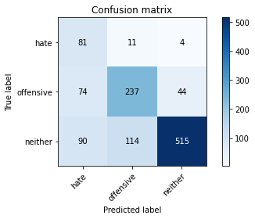

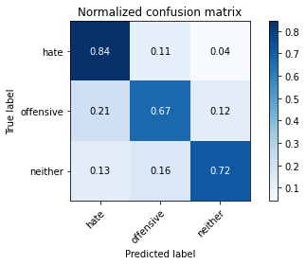

precision recall f1-score support

hate 0.33 0.84 0.48 96

offensive 0.65 0.67 0.66 355

neither 0.91 0.72 0.80 719

accuracy 0.71 1170

macro avg 0.63 0.74 0.65 1170

weighted avg 0.79 0.71 0.73 1170

average eval_loss: 0.7838226844698696, accuracy: 0.711965811965812

training 4 epoch...

16.703897953033447 seconds used......

4 training finished! average train loss: 0.434052928550435

total clf loss: 11.736963041126728 total adv loss: 6.2850004732608795

evaluating...

Confusion matrix, without normalization

[[ 85 10 1]

[ 80 227 48]

[118 119 482]]

Normalized confusion matrix

[[0.88541667 0.10416667 0.01041667]

[0.22535211 0.63943662 0.13521127]

[0.16411683 0.16550765 0.67037552]]

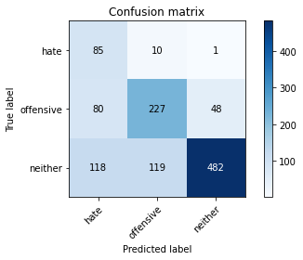

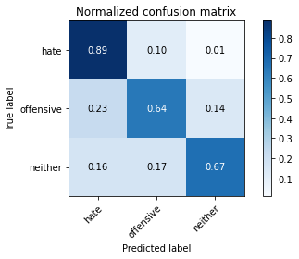

precision recall f1-score support

hate 0.30 0.89 0.45 96

offensive 0.64 0.64 0.64 355

neither 0.91 0.67 0.77 719

accuracy 0.68 1170

macro avg 0.62 0.73 0.62 1170

weighted avg 0.78 0.68 0.70 1170

average eval_loss: 1.019455887503543, accuracy: 0.6786324786324787

training 5 epoch...

16.76822519302368 seconds used......

5 training finished! average train loss: 0.1807379982035075

total clf loss: 5.998083561658859 total adv loss: 2.0616221603704616

evaluating...

Confusion matrix, without normalization

[[ 78 8 10]

[ 68 192 95]

[ 85 49 585]]

Normalized confusion matrix

[[0.8125 0.08333333 0.10416667]

[0.1915493 0.54084507 0.26760563]

[0.11821975 0.06815021 0.81363004]]

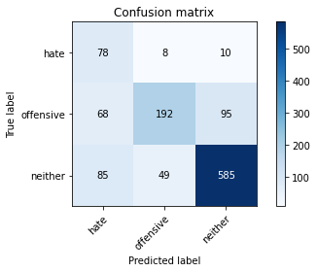

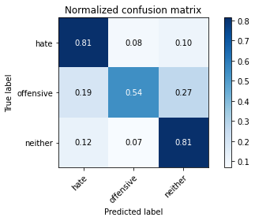

precision recall f1-score support

hate 0.34 0.81 0.48 96

offensive 0.77 0.54 0.64 355

neither 0.85 0.81 0.83 719

accuracy 0.73 1170

macro avg 0.65 0.72 0.65 1170

weighted avg 0.78 0.73 0.74 1170

average eval_loss: 0.9711314813565399, accuracy: 0.7307692307692307

training 6 epoch...

16.745370864868164 seconds used......

6 training finished! average train loss: 0.16278655401297978

total clf loss: 4.2700055334717035 total adv loss: 2.423020760586951

evaluating...

Confusion matrix, without normalization

[[ 70 16 10]

[ 52 247 56]

[ 69 119 531]]

Normalized confusion matrix

[[0.72916667 0.16666667 0.10416667]

[0.14647887 0.69577465 0.15774648]

[0.09596662 0.16550765 0.73852573]]

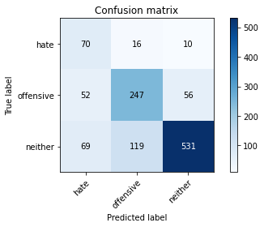

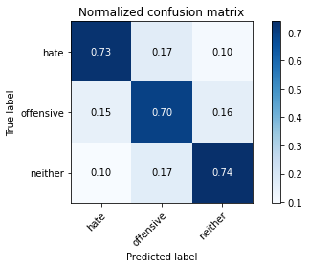

precision recall f1-score support

hate 0.37 0.73 0.49 96

offensive 0.65 0.70 0.67 355

neither 0.89 0.74 0.81 719

accuracy 0.72 1170

macro avg 0.63 0.72 0.66 1170

weighted avg 0.77 0.72 0.74 1170

average eval_loss: 1.0325682521876642, accuracy: 0.7247863247863248

training 7 epoch...

16.707051277160645 seconds used......

7 training finished! average train loss: 0.11565190229365337

total clf loss: 2.741018638946116 total adv loss: 1.8677439218736254

evaluating...

Confusion matrix, without normalization

[[ 90 3 3]

[132 180 43]

[168 75 476]]

Normalized confusion matrix

[[0.9375 0.03125 0.03125 ]

[0.37183099 0.50704225 0.12112676]

[0.23365786 0.10431154 0.6620306 ]]

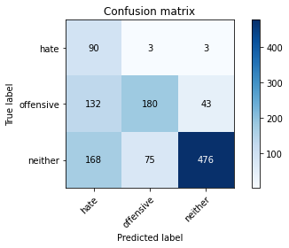

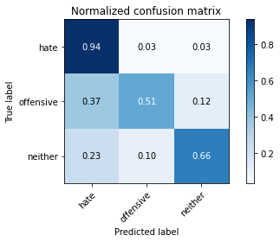

precision recall f1-score support

hate 0.23 0.94 0.37 96

offensive 0.70 0.51 0.59 355

neither 0.91 0.66 0.77 719

accuracy 0.64 1170

macro avg 0.61 0.70 0.57 1170

weighted avg 0.79 0.64 0.68 1170

average eval_loss: 1.5847304488642742, accuracy: 0.6376068376068376

training 8 epoch...

16.685445547103882 seconds used......

8 training finished! average train loss: 0.07658768345053042

total clf loss: 2.161637257784605 total adv loss: 1.0636364913007128

evaluating...

Confusion matrix, without normalization

[[ 68 16 12]

[ 47 216 92]

[ 54 60 605]]

Normalized confusion matrix

[[0.70833333 0.16666667 0.125 ]

[0.13239437 0.6084507 0.25915493]

[0.07510431 0.08344924 0.84144645]]

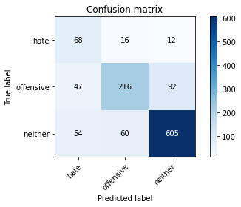

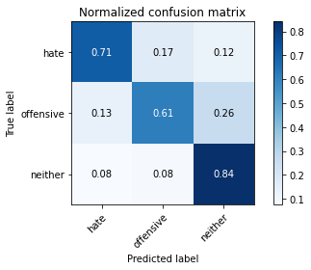

precision recall f1-score support

hate 0.40 0.71 0.51 96

offensive 0.74 0.61 0.67 355

neither 0.85 0.84 0.85 719

accuracy 0.76 1170

macro avg 0.67 0.72 0.68 1170

weighted avg 0.78 0.76 0.77 1170

average eval_loss: 1.0580001539092954, accuracy: 0.7598290598290598

training 9 epoch...

16.778963804244995 seconds used......

9 training finished! average train loss: 0.08106450778931114

total clf loss: 1.9123903345316648 total adv loss: 1.3136110428968095

evaluating...

Confusion matrix, without normalization

[[ 78 6 12]

[ 78 197 80]

[ 88 49 582]]

Normalized confusion matrix

[[0.8125 0.0625 0.125 ]

[0.21971831 0.55492958 0.22535211]

[0.12239221 0.06815021 0.80945758]]

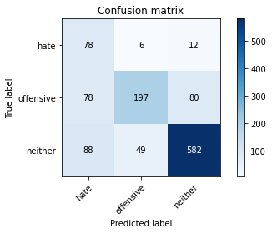

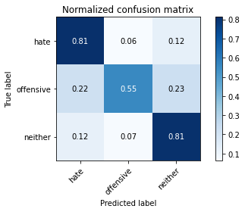

precision recall f1-score support

hate 0.32 0.81 0.46 96

offensive 0.78 0.55 0.65 355

neither 0.86 0.81 0.84 719

accuracy 0.73 1170

macro avg 0.65 0.73 0.65 1170

weighted avg 0.79 0.73 0.75 1170

average eval_loss: 1.2529060588044636, accuracy: 0.7324786324786324

training 10 epoch...

16.723507404327393 seconds used......

10 training finished! average train loss: 0.04893188113679311

total clf loss: 1.0247672805562615 total adv loss: 0.857709036936285

evaluating...

Confusion matrix, without normalization

[[ 81 8 7]

[ 91 206 58]

[108 83 528]]

Normalized confusion matrix

[[0.84375 0.08333333 0.07291667]

[0.25633803 0.58028169 0.16338028]

[0.15020862 0.11543811 0.73435327]]

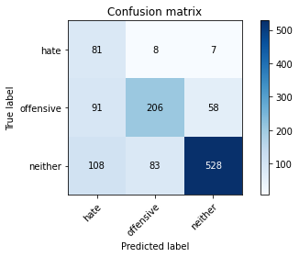

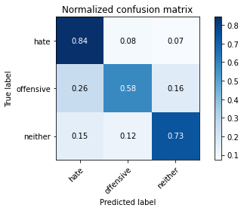

precision recall f1-score support

hate 0.29 0.84 0.43 96

offensive 0.69 0.58 0.63 355

neither 0.89 0.73 0.80 719

accuracy 0.70 1170

macro avg 0.62 0.72 0.62 1170

weighted avg 0.78 0.70 0.72 1170

average eval_loss: 1.5172132427914669, accuracy: 0.6965811965811965

4 run......

training 1 epoch...

16.716711044311523 seconds used......

1 training finished! average train loss: 2.180196312921388

total clf loss: 54.000941038131714 total adv loss: 34.04502621293068

evaluating...

Confusion matrix, without normalization

[[ 82 10 4]

[ 93 214 48]

[122 142 455]]

Normalized confusion matrix

[[0.85416667 0.10416667 0.04166667]

[0.26197183 0.6028169 0.13521127]

[0.16968011 0.19749652 0.63282337]]

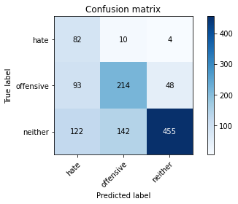

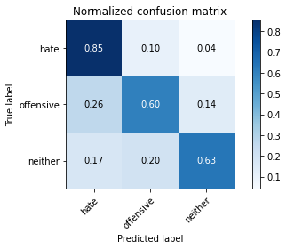

precision recall f1-score support

hate 0.28 0.85 0.42 96

offensive 0.58 0.60 0.59 355

neither 0.90 0.63 0.74 719

accuracy 0.64 1170

macro avg 0.59 0.70 0.58 1170

weighted avg 0.75 0.64 0.67 1170

average eval_loss: 0.8083132939823603, accuracy: 0.6418803418803419

training 2 epoch...

16.817453384399414 seconds used......

2 training finished! average train loss: 1.4896863773465157

total clf loss: 34.22304078936577 total adv loss: 24.599698185920715

evaluating...

Confusion matrix, without normalization

[[ 83 10 3]

[ 78 233 44]

[ 98 130 491]]

Normalized confusion matrix

[[0.86458333 0.10416667 0.03125 ]

[0.21971831 0.65633803 0.12394366]

[0.13630042 0.18080668 0.68289291]]

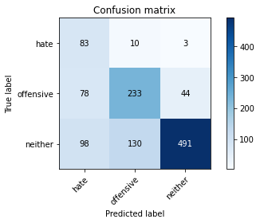

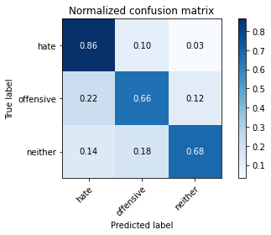

precision recall f1-score support

hate 0.32 0.86 0.47 96

offensive 0.62 0.66 0.64 355

neither 0.91 0.68 0.78 719

accuracy 0.69 1170

macro avg 0.62 0.73 0.63 1170

weighted avg 0.78 0.69 0.71 1170

average eval_loss: 0.7423768306182603, accuracy: 0.6897435897435897

training 3 epoch...

16.80725598335266 seconds used......

3 training finished! average train loss: 0.7408645115792751

total clf loss: 17.964212089776993 total adv loss: 11.762100363150239

evaluating...

Confusion matrix, without normalization

[[ 81 13 2]

[ 61 261 33]

[ 98 155 466]]

Normalized confusion matrix

[[0.84375 0.13541667 0.02083333]

[0.17183099 0.73521127 0.09295775]

[0.13630042 0.21557719 0.64812239]]

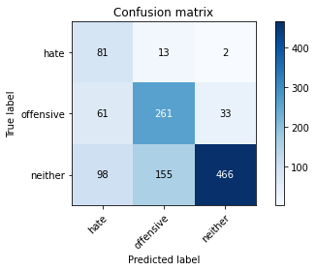

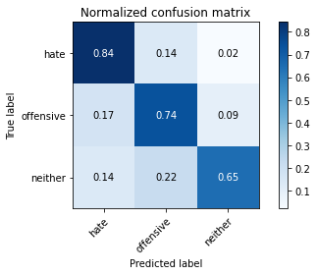

precision recall f1-score support

hate 0.34 0.84 0.48 96

offensive 0.61 0.74 0.67 355

neither 0.93 0.65 0.76 719

accuracy 0.69 1170

macro avg 0.63 0.74 0.64 1170

weighted avg 0.78 0.69 0.71 1170

average eval_loss: 0.8549144187216031, accuracy: 0.6905982905982906

training 4 epoch...

16.734565258026123 seconds used......

4 training finished! average train loss: 0.2849863900004753

total clf loss: 7.252795657142997 total adv loss: 4.353221172466874

evaluating...

Confusion matrix, without normalization

[[ 85 5 6]

[118 179 58]

[112 65 542]]

Normalized confusion matrix

[[0.88541667 0.05208333 0.0625 ]

[0.33239437 0.50422535 0.16338028]

[0.15577191 0.09040334 0.75382476]]

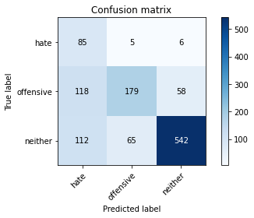

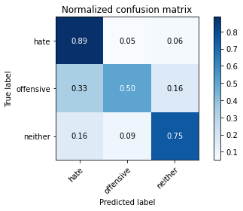

precision recall f1-score support

hate 0.27 0.89 0.41 96

offensive 0.72 0.50 0.59 355

neither 0.89 0.75 0.82 719

accuracy 0.69 1170

macro avg 0.63 0.71 0.61 1170

weighted avg 0.79 0.69 0.72 1170

average eval_loss: 0.9646128405958919, accuracy: 0.6888888888888889

training 5 epoch...

16.778645038604736 seconds used......

5 training finished! average train loss: 0.08724807631889624

total clf loss: 2.9447997249662876 total adv loss: 0.9705462631536648

evaluating...

Confusion matrix, without normalization

[[ 84 7 5]

[ 62 256 37]

[ 84 136 499]]

Normalized confusion matrix

[[0.875 0.07291667 0.05208333]

[0.17464789 0.72112676 0.10422535]

[0.11682893 0.1891516 0.69401947]]

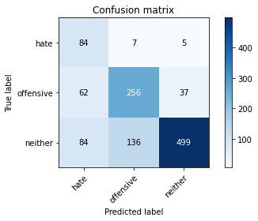

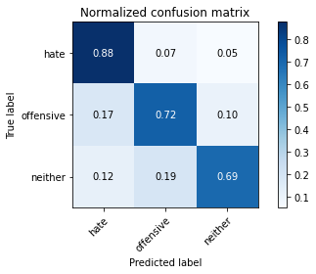

precision recall f1-score support

hate 0.37 0.88 0.52 96

offensive 0.64 0.72 0.68 355

neither 0.92 0.69 0.79 719

accuracy 0.72 1170

macro avg 0.64 0.76 0.66 1170

weighted avg 0.79 0.72 0.74 1170

average eval_loss: 1.0397925311225955, accuracy: 0.7170940170940171

training 6 epoch...

16.78510856628418 seconds used......

6 training finished! average train loss: 0.09881625657102891

total clf loss: 2.1342069637030363 total adv loss: 1.699751685911906

evaluating...

Confusion matrix, without normalization

[[ 84 8 4]

[ 66 241 48]

[ 87 134 498]]

Normalized confusion matrix

[[0.875 0.08333333 0.04166667]

[0.18591549 0.67887324 0.13521127]

[0.12100139 0.18636996 0.69262865]]

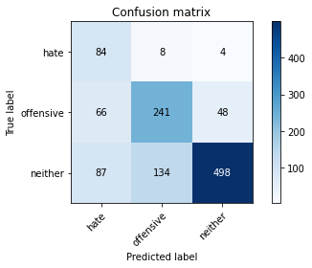

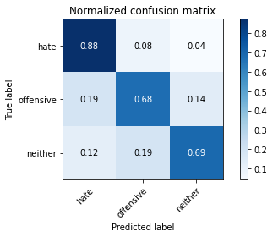

precision recall f1-score support

hate 0.35 0.88 0.50 96

offensive 0.63 0.68 0.65 355

neither 0.91 0.69 0.78 719

accuracy 0.70 1170

macro avg 0.63 0.75 0.65 1170

weighted avg 0.78 0.70 0.72 1170

average eval_loss: 1.1143922714863794, accuracy: 0.7034188034188035

training 7 epoch...

16.706438779830933 seconds used......

7 training finished! average train loss: 0.08810231127842728

total clf loss: 1.922182835638523 total adv loss: 1.5057733396533877

evaluating...

Confusion matrix, without normalization

[[ 86 5 5]

[100 162 93]

[ 86 43 590]]

Normalized confusion matrix

[[0.89583333 0.05208333 0.05208333]

[0.28169014 0.45633803 0.26197183]

[0.11961057 0.05980529 0.82058414]]

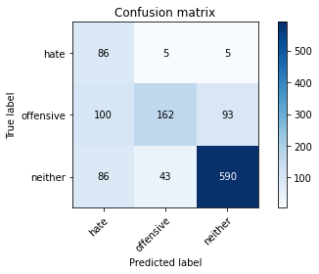

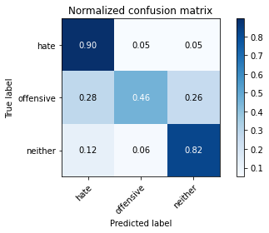

precision recall f1-score support

hate 0.32 0.90 0.47 96

offensive 0.77 0.46 0.57 355

neither 0.86 0.82 0.84 719

accuracy 0.72 1170

macro avg 0.65 0.72 0.63 1170

weighted avg 0.79 0.72 0.73 1170

average eval_loss: 1.2240148573103597, accuracy: 0.7162393162393162

training 8 epoch...

16.774951457977295 seconds used......

8 training finished! average train loss: 0.059542726093371

total clf loss: 1.2820774929132313 total adv loss: 1.0261575687181903

evaluating...

Confusion matrix, without normalization

[[ 81 8 7]

[ 75 199 81]

[ 80 59 580]]

Normalized confusion matrix

[[0.84375 0.08333333 0.07291667]

[0.21126761 0.56056338 0.22816901]

[0.11126565 0.08205841 0.80667594]]

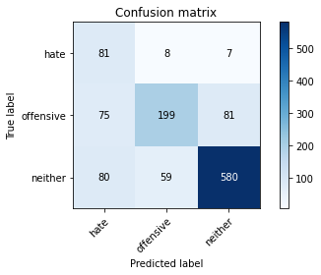

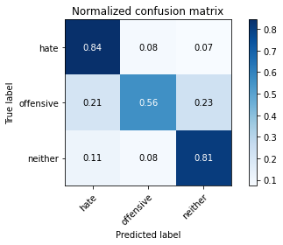

precision recall f1-score support

hate 0.34 0.84 0.49 96

offensive 0.75 0.56 0.64 355

neither 0.87 0.81 0.84 719

accuracy 0.74 1170

macro avg 0.65 0.74 0.66 1170

weighted avg 0.79 0.74 0.75 1170

average eval_loss: 1.0135728459236986, accuracy: 0.7350427350427351

training 9 epoch...

16.796541213989258 seconds used......

9 training finished! average train loss: 0.06025479506102523

total clf loss: 1.1982025454053655 total adv loss: 1.0880330008003511

evaluating...

Confusion matrix, without normalization

[[ 76 14 6]

[ 64 240 51]

[ 91 102 526]]

Normalized confusion matrix

[[0.79166667 0.14583333 0.0625 ]

[0.18028169 0.67605634 0.14366197]

[0.12656467 0.1418637 0.73157163]]

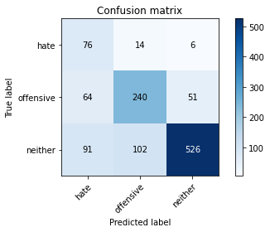

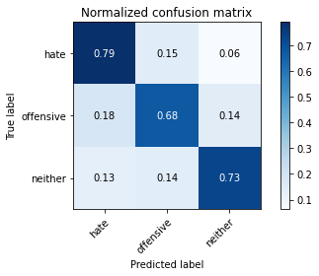

precision recall f1-score support

hate 0.33 0.79 0.46 96

offensive 0.67 0.68 0.68 355

neither 0.90 0.73 0.81 719

accuracy 0.72 1170

macro avg 0.64 0.73 0.65 1170

weighted avg 0.79 0.72 0.74 1170

average eval_loss: 1.1290958897542145, accuracy: 0.7196581196581197

training 10 epoch...

16.697657108306885 seconds used......

10 training finished! average train loss: 0.07234649960550346

total clf loss: 1.5993939142790623 total adv loss: 1.2260050351906102

evaluating...

Confusion matrix, without normalization

[[ 78 7 11]

[ 71 206 78]

[ 51 67 601]]

Normalized confusion matrix

[[0.8125 0.07291667 0.11458333]

[0.2 0.58028169 0.21971831]

[0.07093185 0.09318498 0.83588317]]

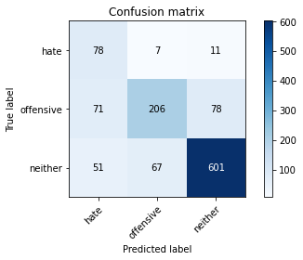

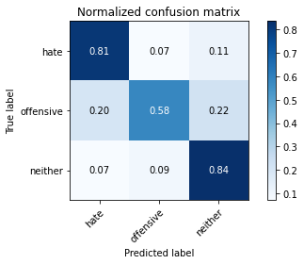

precision recall f1-score support

hate 0.39 0.81 0.53 96

offensive 0.74 0.58 0.65 355

neither 0.87 0.84 0.85 719

accuracy 0.76 1170

macro avg 0.67 0.74 0.68 1170

weighted avg 0.79 0.76 0.76 1170

average eval_loss: 1.1358605053717807, accuracy: 0.7564102564102564

5 run......

training 1 epoch...

16.722455739974976 seconds used......

1 training finished! average train loss: 2.19330951997212

total clf loss: 55.669339299201965 total adv loss: 33.57799732685089

evaluating...

Confusion matrix, without normalization

[[ 89 3 4]

[251 69 35]

[264 35 420]]

Normalized confusion matrix

[[0.92708333 0.03125 0.04166667]

[0.70704225 0.1943662 0.09859155]

[0.36717663 0.04867872 0.58414465]]

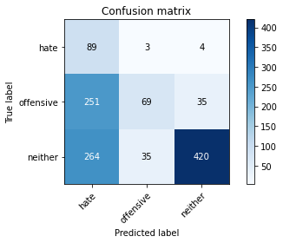

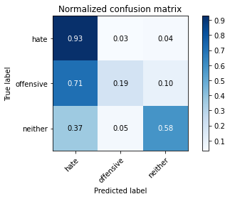

precision recall f1-score support

hate 0.15 0.93 0.25 96

offensive 0.64 0.19 0.30 355

neither 0.92 0.58 0.71 719

accuracy 0.49 1170

macro avg 0.57 0.57 0.42 1170

weighted avg 0.77 0.49 0.55 1170

average eval_loss: 0.9820212681414717, accuracy: 0.49401709401709404

training 2 epoch...

16.80625033378601 seconds used......

2 training finished! average train loss: 1.5849599848900522

total clf loss: 37.76135295629501 total adv loss: 25.49820300936699

evaluating...

Confusion matrix, without normalization

[[ 71 20 5]

[ 56 273 26]

[ 92 198 429]]

Normalized confusion matrix

[[0.73958333 0.20833333 0.05208333]

[0.15774648 0.76901408 0.07323944]

[0.12795549 0.27538248 0.59666203]]

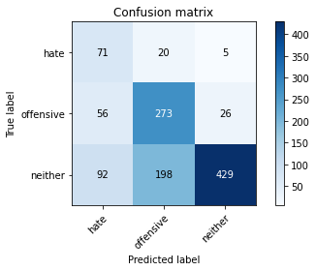

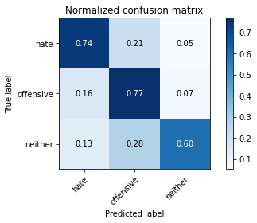

precision recall f1-score support

hate 0.32 0.74 0.45 96

offensive 0.56 0.77 0.65 355

neither 0.93 0.60 0.73 719

accuracy 0.66 1170

macro avg 0.60 0.70 0.61 1170

weighted avg 0.77 0.66 0.68 1170

average eval_loss: 0.7971081279091916, accuracy: 0.6606837606837607

training 3 epoch...

16.72604250907898 seconds used......

3 training finished! average train loss: 0.8144634919507163

total clf loss: 20.799055106937885 total adv loss: 12.405450159683824

evaluating...

Confusion matrix, without normalization

[[ 80 9 7]

[ 86 220 49]

[100 99 520]]

Normalized confusion matrix

[[0.83333333 0.09375 0.07291667]

[0.24225352 0.61971831 0.13802817]

[0.13908206 0.13769124 0.7232267 ]]

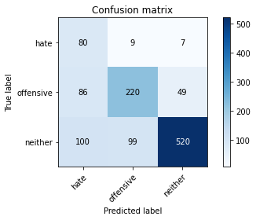

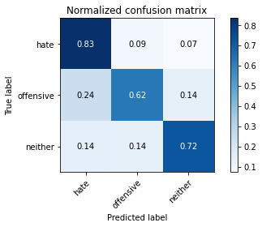

precision recall f1-score support

hate 0.30 0.83 0.44 96

offensive 0.67 0.62 0.64 355

neither 0.90 0.72 0.80 719

accuracy 0.70 1170

macro avg 0.62 0.73 0.63 1170

weighted avg 0.78 0.70 0.73 1170

average eval_loss: 0.7556198966705193, accuracy: 0.7008547008547008

training 4 epoch...

16.712154626846313 seconds used......

4 training finished! average train loss: 0.29558014909603764

total clf loss: 8.887992575764656 total adv loss: 3.8322477801702917

evaluating...

Confusion matrix, without normalization

[[ 82 7 7]

[ 77 228 50]

[ 79 100 540]]

Normalized confusion matrix

[[0.85416667 0.07291667 0.07291667]

[0.21690141 0.64225352 0.14084507]

[0.10987483 0.13908206 0.75104312]]

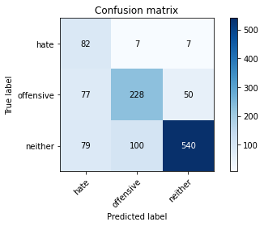

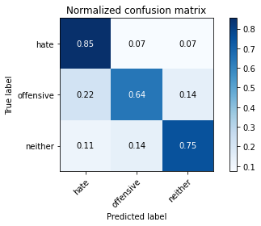

precision recall f1-score support

hate 0.34 0.85 0.49 96

offensive 0.68 0.64 0.66 355

neither 0.90 0.75 0.82 719

accuracy 0.73 1170

macro avg 0.64 0.75 0.66 1170

weighted avg 0.79 0.73 0.75 1170

average eval_loss: 0.81770680011329, accuracy: 0.7264957264957265

training 5 epoch...

16.778083324432373 seconds used......

5 training finished! average train loss: 0.12749115620473667

total clf loss: 4.2694147285074 total adv loss: 1.435044983169064

evaluating...

Confusion matrix, without normalization

[[ 85 6 5]

[105 200 50]

[115 80 524]]

Normalized confusion matrix

[[0.88541667 0.0625 0.05208333]

[0.29577465 0.56338028 0.14084507]

[0.15994437 0.11126565 0.72878999]]

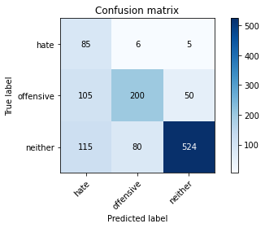

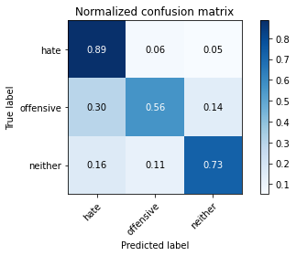

precision recall f1-score support

hate 0.28 0.89 0.42 96

offensive 0.70 0.56 0.62 355

neither 0.91 0.73 0.81 719

accuracy 0.69 1170

macro avg 0.63 0.73 0.62 1170

weighted avg 0.79 0.69 0.72 1170

average eval_loss: 1.0327364110340507, accuracy: 0.6914529914529914

training 6 epoch...

16.78093457221985 seconds used......

6 training finished! average train loss: 0.0559712330162126

total clf loss: 2.2283861790783703 total adv loss: 0.4530014477641089

evaluating...

Confusion matrix, without normalization

[[ 66 24 6]

[ 44 274 37]

[ 64 174 481]]

Normalized confusion matrix

[[0.6875 0.25 0.0625 ]

[0.12394366 0.77183099 0.10422535]

[0.08901252 0.24200278 0.6689847 ]]

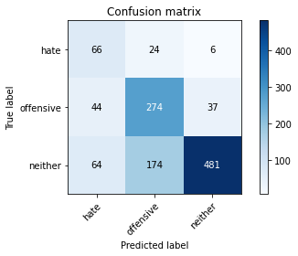

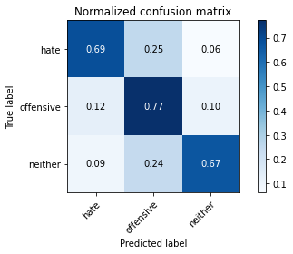

precision recall f1-score support

hate 0.38 0.69 0.49 96

offensive 0.58 0.77 0.66 355

neither 0.92 0.67 0.77 719

accuracy 0.70 1170

macro avg 0.63 0.71 0.64 1170

weighted avg 0.77 0.70 0.72 1170

average eval_loss: 1.083666830749835, accuracy: 0.7017094017094017

training 7 epoch...

16.743483304977417 seconds used......

7 training finished! average train loss: 0.021479378412810286

total clf loss: 0.8185315011069179 total adv loss: 0.19215684658047394

evaluating...

Confusion matrix, without normalization

[[ 77 13 6]

[ 74 230 51]

[ 75 128 516]]

Normalized confusion matrix

[[0.80208333 0.13541667 0.0625 ]

[0.2084507 0.64788732 0.14366197]

[0.10431154 0.17802503 0.71766342]]

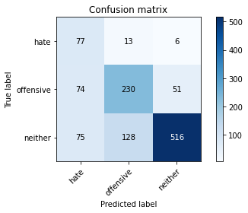

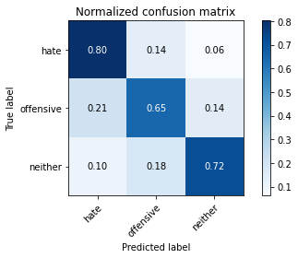

precision recall f1-score support

hate 0.34 0.80 0.48 96

offensive 0.62 0.65 0.63 355

neither 0.90 0.72 0.80 719

accuracy 0.70 1170

macro avg 0.62 0.72 0.64 1170

weighted avg 0.77 0.70 0.72 1170

average eval_loss: 1.1863112055649192, accuracy: 0.7034188034188035

training 8 epoch...

16.828829765319824 seconds used......

8 training finished! average train loss: 0.1948658921839004

total clf loss: 3.342584365280345 total adv loss: 3.7849527999205748

evaluating...

Confusion matrix, without normalization

[[ 85 5 6]

[100 186 69]

[103 77 539]]

Normalized confusion matrix

[[0.88541667 0.05208333 0.0625 ]

[0.28169014 0.52394366 0.1943662 ]

[0.14325452 0.10709318 0.74965229]]

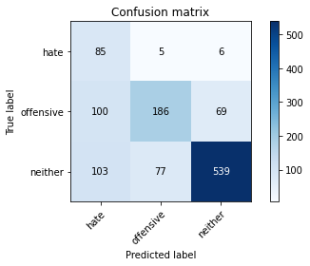

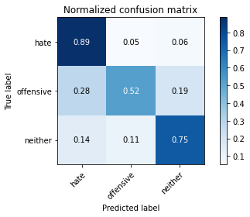

precision recall f1-score support

hate 0.30 0.89 0.44 96

offensive 0.69 0.52 0.60 355

neither 0.88 0.75 0.81 719

accuracy 0.69 1170

macro avg 0.62 0.72 0.62 1170

weighted avg 0.77 0.69 0.71 1170

average eval_loss: 1.0693138721635786, accuracy: 0.6923076923076923

training 9 epoch...

16.781866550445557 seconds used......

9 training finished! average train loss: 0.07384071918204427

total clf loss: 1.5883688693866134 total adv loss: 1.2733557115425356

evaluating...

Confusion matrix, without normalization

[[ 67 21 8]

[ 49 244 62]

[ 54 111 554]]

Normalized confusion matrix

[[0.69791667 0.21875 0.08333333]

[0.13802817 0.68732394 0.17464789]

[0.07510431 0.15438108 0.7705146 ]]

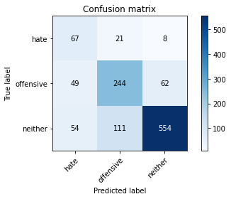

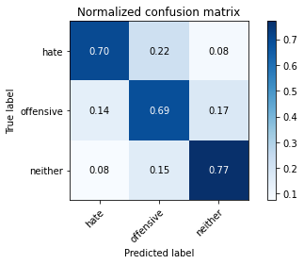

precision recall f1-score support

hate 0.39 0.70 0.50 96

offensive 0.65 0.69 0.67 355

neither 0.89 0.77 0.83 719

accuracy 0.74 1170

macro avg 0.64 0.72 0.67 1170

weighted avg 0.77 0.74 0.75 1170

average eval_loss: 0.9647955783342911, accuracy: 0.7393162393162394

training 10 epoch...

16.67904257774353 seconds used......

10 training finished! average train loss: 0.028935047592053058

total clf loss: 0.9991620130604133 total adv loss: 0.3106003242901352

evaluating...

Confusion matrix, without normalization

[[ 59 31 6]

[ 28 284 43]

[ 48 154 517]]

Normalized confusion matrix

[[0.61458333 0.32291667 0.0625 ]

[0.07887324 0.8 0.12112676]

[0.06675939 0.21418637 0.71905424]]

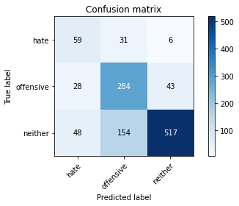

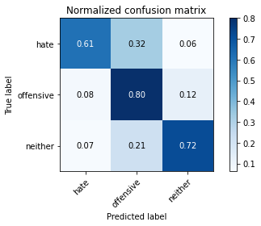

precision recall f1-score support

hate 0.44 0.61 0.51 96

offensive 0.61 0.80 0.69 355

neither 0.91 0.72 0.80 719

accuracy 0.74 1170

macro avg 0.65 0.71 0.67 1170

weighted avg 0.78 0.74 0.75 1170

average eval_loss: 1.1730398363986259, accuracy: 0.7350427350427351